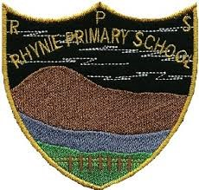
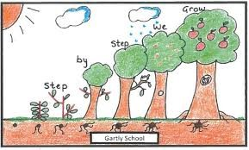
Rhynie and Gartly Nursery
April 2021 Newsletter
Hello everyone! Here is our last newsletter for Term 3. We hope all the children have enjoyed being back in school and nursery, we certainly have.
- Our last day for Term 3 is Thursday the 1st April and we will return for Term 4 on Monday the 19th April.
- As Mrs Morrison is sadly leaving us, we are planning to hold a tea party on Thursday. We wish her all the luck in her new job and know that Tarland Nursery is gaining a brilliant manager. Mrs Kat Douglas will still be Early Years Senior Practitioner on Monday, Tuesday and Wednesday and her job share has been advertised.
- Mrs Douglas and Miss Crawford are in the process of interviewing new practitioners to add to our great team within the nursery. We will update you of who the new staff are once they are in position.
- Within nursery this term, we have focused heavily on settling into nursery (as a new start or a returner). We have created new friendships and familiarised ourselves with the nursery routines and the new environment both inside and out.
- Next term we are hoping to focus on planting and more adventures out and about in the community – we found frog spawn in the local woods, so this has sparked interesting conversations amongst the children.
- Currently we have been exploring ‘nurture’ - We have planted sunflower seeds and have been taking care of them in nursery. Can we ask each child to please take care of their sunflower at home over the spring holidays? This will help reinforce learning about responsibility and taking care of a living thing.
REMINDERS…
- Please can you ensure there is a change of clothes in your child’s bag, as well as waterproofs, indoor shoes, and wellies?
- Please can we also ask that personal toys stay at home. We don’t want upset children if they get lost or broken, and due to COVID-19 we need to reduce the risk of cross contamination as much as possible. The only toys that may come into nursery are comforters that the child may need to refer to in tough times.

We hope you all enjoy the break over the next two weeks, we are hoping for the sun to be shining! See you all back again on the 19th

Rhynie/Gartly Nursery Team

