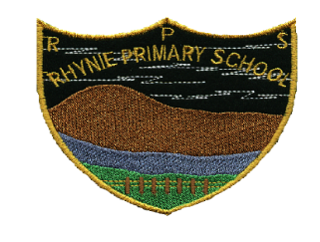

**Rhynie School – Curriculum Learning Plan**

|  |  |
| --- | --- |
| **Class 1** | **Term 1 2023 – 24** |
|  |  |
| **Language and Literacy** | Jolly Phonics Sounds and Digraphs, Alphabet Names, Formation of Letters, Handwriting Skills, Listening Skills, Cutting Skills / Hand Control Activities, Sentence Writing  Short Stories, Nelson Spelling, Nelson Grammar, Reading, Word building activities. |
|  |  |
| **Modern Languages** | French - Greetings and Common Vocabulary. |
|  |  |
| **Maths and Numeracy** | Numbers to 10 / 100/ 1000 – write, recognise, understand place value. |
|  |  |
| **Health and Wellbeing** | **P.E.** with Ms. Hardy on Tuesday morning. This term the focus is gymnastics including floor work, small and large apparatus and movement.  RHYNIE Values and Aims  Safe September – Keeping ourselves safe.  Healthy October – Keeping our bodies healthy. |
|  |  |
| **I.T** | Logging into and navigating TEAMS, educational games, using the clevertouch board. |
|  |  |
| **Drama** | Children will take part in a drama programme which involves listening skills and following instructions. |
|  |  |
| **Opportunities for personal achievement/development** | Garden Gang  Bees and Kindness Nominations  Line Leader / Class Helpers |
|  |  |
| **Homework** | Reading and associated work (workbook or skills)  Spelling |