Rhynie Primary School
Child Protection Policy
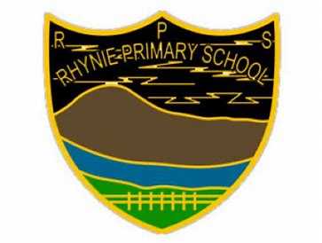

February 2024

Contents
__________________________________________________________________

Introduction and Purpose 4
___________________________________________________________________

Part 1 – The Context for Child Protection 5

- Definitions of ‘child’ 5

- Child experience 5

- Definitions of ‘parents’ and ‘carers’ 6

- What is child abuse and neglect? 7 - 8

- GIRFEC Approach 8

- Information sharing 8

- What is ‘harm’ and ‘significant harm’ in the child protection context? 9

- What is the Child Protection Register 9

- Removing a child from the Child Protection Register 9
___________________________________________________________________

Part 2 – Roles and Responsibilities 10

- Responsibilities of All 10

- Children Missing from Education (CME) 10

- PREVENT 10

- Equal Protection 10

- Individual Roles 11

- Director of Education 11
- Head of Education 11
- Head Teachers and Service Managers 11
- Child Protection Coordinators 12
- Individual Staff Members 13
- Visiting Staff 13

- Out of hours procedures 13

- Children’s Services Social Work 14

- Child Protection Training 14

- Staff Induction 14
___________________________________________________________________

___________________________________________________________________

Part 3 – Identifying and Responding to Concerns about Children 15

- Stepped process 15 - 16

- Supporting children and Informing Parents 16

- When there is a decision not to initiate Child Protection Procedures 16

- Inter-agency Referral Discussions 16

- Joint Investigative Interviews 16

- Health and Medical Assessments 17

- Emergency Legal Measures 17

- Child Protection Planning Meetings 17

- Child Protection Plans 17
___________________________________________________________________

Child Protection in Education Guidance Update Information 18

Introduction

Child Protection is the responsibility of all who work with children and families regardless of whether or not they come into direct contact with children. All staff must be fully informed of their responsibilities in respect of keeping children safe. All services working with children, young people and families are expected to identify and consider the wellbeing of children and to share concerns appropriately.

It is recognised that physical and emotional safety provides a foundation for wellbeing and healthy development and the purpose of this Aberdeenshire Guidance is to help protect children and young people and to build the confidence of staff working within Aberdeenshire Educational Establishments to work safely with children and to take responsibility for protecting them.

These guidelines are based on the National Guidance for Child Protection in Scotland 2021- updated 2023. The National Guidance describes responsibilities and expectations for all involved in protecting children in Scotland. It outlines how statutory and non-government agencies should work together with parents, families and communities to prevent harm and to protect children from abuse and neglect. Everyone has a role in protecting children from harm.

Purpose

The purpose of this guidance is to assist all employees who work with children, young people and families in Aberdeenshire Educational Establishments (Rhynie Primary School) by:
- developing an ethos which safeguards and promotes the welfare and wellbeing of all children
- providing clear guidance for all staff on the roles and responsibilities involved in child protection
- ensuring that staff respond appropriately when abuse is identified
- describing the processes and procedures that all staff must follow in response to disclosure, allegation or suspicion of child abuse
- ensuring effective multi-agency communication, collaborative working and providing a consistent framework for practice.

This guidance applies to all employees, volunteers and others working with children and young people within Educational Establishments.

Part 1
The Context for Child Protection

Every child or young person has the “right to be protected from all forms of harm and abuse”. National Guidance for Child Protection in Scotland 2021-updated 2023.
Abuse and neglect are forms of maltreatment and may involve inflicting harm or failing to act to prevent harm.

Definitions of ‘child’
This Aberdeenshire guidance apply to children and young people up to the age of 18 who attend school or are eligible to access services. Throughout the guidance, where a child/ren are referenced, this applies equally to young people.

Sections 1.7 – 1.22 of the National Guidance for Child Protection in Scotland 2021-updated 2023 provides a detailed explanation of the legal context in which a young person up to the age of 18 years may be considered as a child.

Child’s Experience
The Child’s experience, views and needs are central within Child Protection processes. Talking with and listening to children means attention not only to their words, but also to their experience, needs, wishes and feelings.

Children should be involved in decision-making in ways that are attuned to the needs and understanding of each child and with a Trauma Informed approach. They must be helped to understand how Child Protection procedures work, how they can be involved, and how they contribute to decisions about their future. Advocacy services may assist in this process. Some children may have experienced grooming, or coercion including threats, and they may fear reprisal if they disclose.

Information and guidance on understanding and responding to children affected by trauma can be found within the ALDO Trauma Informed and Trauma Skilled online courses. Further support materials can be found within the National Trauma Framework.

Below details the expectations from children who may be involved in child protection processes. National Guidance for Child Protection in Scotland 2021
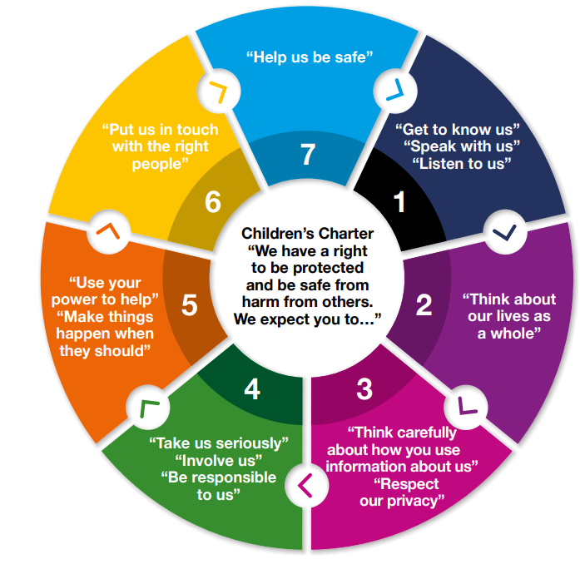

Definitions of parents and carers

A parent is defined as someone who is the genetic or adoptive mother or father of a child. This is subject to the Human Fertilisation and Embryology Act 2008 which sets out which persons are able to be treated as parents of a child conceived through assistive reproduction.

A mother automatically has parental rights and responsibilities (PRRs). A father automatically has PRRs if he is or was married to the mother at the time of the child’s conception or subsequently. If a father is not married to the mother, he will acquire PRRs if he is registered as the child’s father on the child’s birth certificate, which requires the mother’s agreement as this must have been registered jointly with the child’s mother. A father can also acquire PRRs by completing and registering a Parental Responsibilities and Rights agreement with the mother or obtaining a court order.

A carer is someone other than a parent who looks after a child. This includes ‘kinship’ and ‘foster’ carers. Throughout this guidance, where a parent is referenced, this applies equally to carers.

Sections 1.23-1.32 of the National Guidance for Child Protection in Scotland 2021-updated 2023 provides detailed definitions of parents and carers, including same-sex couples.

When working with parents it is essential that a trauma informed approach is taken, where there is an understand of how the impact of trauma may affect how a parent responds to professionals. Being trauma informed means that staff adapt how they work so that no further harm is caused, and the impact of trauma does not create a barrier to positive working relationships with parents.

Further advice for working with parents can be found within the Trauma Informed ALDO course, to support schools to ensure that trauma informed practice is embedded at a all levels.

Below details the expectations from parents who may be involved in child protection processes. National Guidance for Child Protection in Scotland 2021-updated 2023
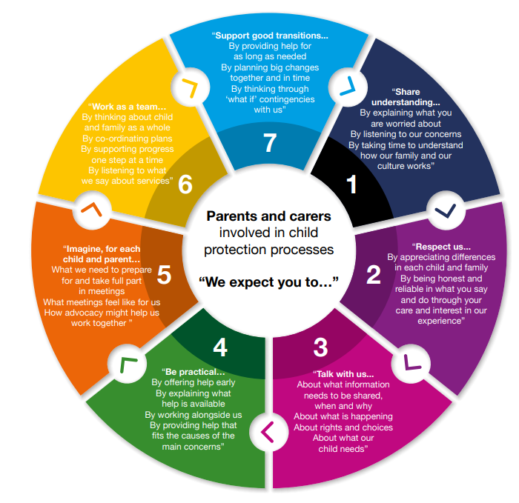

What is child abuse and child neglect?
Abuse and neglect are forms of maltreatment. Abuse or neglect may involve inflicting harm or failing to act to prevent harm. Children may be maltreated at home; within a family or peer network; in care placements; institutions or community settings; and in the online and digital environment.

Physical abuse
Physical abuse is the causing of physical harm to a child or young person. Physical abuse may involve hitting, shaking, throwing, poisoning, burning or scalding, drowning or suffocating. Physical harm may also be caused when a parent or carer feigns the symptoms of, or deliberately causes, ill health to a child they are looking after.

Emotional abuse
Emotional abuse is persistent emotional ill treatment that has severe and persistent adverse effects on a child’s emotional development. ‘Persistent’ means there is a continuous or intermittent pattern which has caused, or is likely to cause, significant harm. Emotional abuse is present to some extent in all types of ill treatment of a child, but it can also occur independently of other forms of abuse.

Sexual abuse

Child sexual abuse (CSA) is an act that involves a child in any activity for the sexual gratification of another person. A child under age 16 cannot consent to sexual activity at all, so it cannot be claimed that the child consented or assented to such activity. The position for children aged 16/17 will depend on whether there is consent or a reasonable belief of consent. Some sexual offences, such as sexual abuse of trust, apply up to the age of 18 irrespective of consent.

Sexual abuse may involve physical contact, including penetrative or non-penetrative acts. They may include non-contact activities, such as involving children in looking at or in the production of indecent images, in watching sexual activities, using sexual language towards a child, or encouraging children to behave in sexually inappropriate ways.

Child sexual exploitation (CSE) is a form of child sexual abuse. It occurs where an individual or group takes advantage of an imbalance of power to coerce, manipulate or deceive a person under 18 into sexual activity in exchange for something the victim needs or wants, and/or for the financial advantage or increased status of the perpetrator or facilitator. The victim may have been sexually exploited even if the sexual activity appears consensual. Child sexual exploitation does not always involve physical contact. It can also occur through the use of technology.

For those who may be victims of sexual offences aged 16-17, child protection procedures should be considered. These procedures must be applied when there is concern about the sexual exploitation or trafficking of a child.

Further information and resources can be found on the Aberdeenshire GIRFEC website

Criminal Exploitation
Criminal exploitation refers to the action of an individual or group using an imbalance of power to coerce, control, manipulate or deceive a child or young person under the age of 18 into any criminal activity in exchange for something the victim needs or wants, or for the financial or other advantage of the perpetrator or facilitator. Violence or the threat of violence may feature. It may involve gangs and organised criminal networks. Sale of illegal drugs may be a feature.

Child trafficking
Child trafficking involves the recruitment, transportation, transfer, harbouring or receipt, exchange or transfer of control of a child under the age of 18 years for the purposes of exploitation. Transfer or movement can be within an area and does not have to be across borders.

Further information and resources can be found on the Aberdeenshire GIRFEC Website

Neglect
Neglect is the ‘persistent’ (meaning there is a pattern which may be continuous or intermittent) failure to meet a child’s basic physical and/or psychological needs which is likely to result in a serious impairment of the child’s health or development. There can also be single instances of neglectful behaviour that cause significant harm. The GIRFEC SHANARRI indicators set out the essential wellbeing needs. Neglect of any or all of these can impact on healthy development.

Further information and resources can be found on the Aberdeenshire Neglect Toolkit

Female genital mutilation
This extreme form of physical, sexual and emotional assault upon girls and women involves partial or total removal of the external female genitalia, or other injury to the female genital organs for non-medical reasons.

Further information and resources can be found on the Aberdeenshire GIRFEC Website

Forced marriage
A forced marriage is a marriage conducted without the full and free consent of both parties and where duress is a factor. Duress can include physical, psychological, financial, sexual, and emotional abuse. Forced marriage is both a child protection and adult protection matter. Child protection processes will be considered up to the age of 18.

What is Child Protection?
Child Protection refers to the processes involved in consideration, assessment and planning of required action, together with the actions themselves, where there are concerns that a child may be at risk of harm. Child Protection procedures (see Part 3) are initiated when police, social work or health professionals determine that a child may have been abused or may be at risk of significant harm.

The Getting it Right for Every Child (GIRFEC) Approach
Child Protection is part of a continuum of collaborative duties. The GIRFEC approach promotes and supports planning in the way that best safeguards, supports and promotes the wellbeing of children, and ensures that any action to meet needs is taken at the earliest, appropriate time to prevent acute needs arising.

Child Protection processes fall at the urgent end of the continuum of services which include prevention and early intervention. The GIRFEC approach underpins both preventative and child protection processes. This includes an identified point of contact to provide early support, advice and access to services, a shared approach to assessment and consideration of wellbeing, and a shared response to identified needs, included planning for children across services where needed.

Information Sharing
Sharing relevant information is an essential part of protecting children from harm. Where there is a child protection concern, relevant information should be shared with police or social work without delay. Where there may be a child protection concern, information may be lawfully shared without the need for consent to be obtained from the individual(s) to whom the information relates.

In relation to Child Protection procedures and confidentiality (see Part 3 for further details), the main points to remember are:

- In the interests of protecting children, employees have a professional obligation to pass on information to relevant agencies
- Employees must not promise to keep secret any allegation or concerns even if a child or third person requests this

Training on information sharing can be found by accessing the ALDO GIRFEC Information Sharing online course.

Further information can be found on within the Aberdeenshire GIRFEC Toolkit

What is harm and significant harm in a child protection context?
Protecting children involves preventing harm and/or the risk of harm from abuse or neglect. A child protection investigation is triggered when the impact of harm is deemed to be significant. ‘Harm’ in this context refers to the ill treatment or the impairment of the health or development of the child.

Forming a view on the significance of harm involves information gathering, putting a concern in context, and analysis of the facts and circumstances. For some actions and legal measures, the test is ‘significant harm’ or risk of ‘significant harm’. There is no legal definition of significant harm or the distinction between harm and significant harm. The extent to which harm is significant will relate to the severity or anticipated severity of impact upon a child’s health and development.

Further information can be found within the Scottish Government National Risk Assessment Toolkit

What is the Child Protection Register (CPR)?
In Scotland the Child Protection Register is a confidential list of all children in the local area who have been identified as being at risk of significant harm. It allows authorised individuals to check if a child they are working with is known to be at risk. If a child is added to the CPR they must also have a Child Protection Plan, which sets out what action needs to be taken by whom and when, in order to safeguard the child and promote their welfare.

Aberdeenshire Children’s Service’s Social Work are responsible for maintaining this register. The decision to place a child’s name on the register is taken following multi-agency assessment and a Child Protection Planning Meeting (CPPM). A child may be placed on the register if there are reasonable grounds to believe or suspect that a child has suffered or will suffer significant harm from abuse or neglect, and that a Child Protection Plan is needed to protect and support the child.

Removing a child from the Child Protection Register
If and when the practitioners who are working with the child and family decide that the risk of significant harm to the child has been sufficiently reduced and the child is no longer in need of a Child Protection Plan, the child’s name will be removed from the Child Protection Register. The decision to remove a child’s name is made through a review CPPM.

Part 2
Roles and Responsibilities

Responsibility of All
Child Protection is the responsibility of all who work with children and families regardless of whether or not they come into direct contact with children. All staff must be fully informed of their responsibilities in respect of keeping children safe.

All services working with children and families are expected to identify and consider the wellbeing of children and to share concerns appropriately. All agencies have a responsibility to recognise and actively consider potential risks to a child, irrespective of whether the child is the main focus of their involvement.

Staff need to be mindful of the complexity of the risks facing some young people and look beyond the obvious. School and early years settings staff play a crucial role in the support and protection of children as well as the development of their wellbeing.

All staff working in education establishments, have a key role in the support and protection of children. Day-to-day professional experience of, and relationship with children is a fundamental protective factor and they are well placed to observe physical and psychological changes in a child which could indicate abuse, exploitation or neglect.

Children Missing from Education (CME)
Where a child goes missing from education, Aberdeenshire’s education central team will conduct investigations in line with the Children Missing from Education Practice Guidance.

PREVENT
Prevent is the Government’s strategy to stop people becoming terrorists or supporting terrorism, in all its forms. This supports and protects vulnerable people who might be susceptible to radicalisation ensuring they are diverted away, before any criminal activity has taken place.
Radicalisation is a form of exploitation and as part of our Child Protection procedures we must be aware of and protect children who may be vulnerable to this. Where a member of staff has a concern that a child has been radicalised or is at risk of being radicalised, they must share this concern with the Child Protection Coordinator as per Child Protection procedures (see Part 3 for further detail).

Further information on PREVENT and Radicalisation can be found within the Child Protection in Education Spotlight Briefings and the ALDO online course PREVENT - Notice, Check, Share.

Equal Protection
On 7 November 2020, the Children (Equal Protection from Assault) (Scotland) Act 2019 was introduced. The Act provides children with the same rights as adults against assault by a parent or person with charge or care of them.

First and foremost, when dealing with children for Equal Protection incidents or any other matter, it must be remembered that ensuring their safety, care and wellbeing is critical. Instances of equal protection which were previously deemed ‘reasonable chastisement’ are now classed as an offence of assault and can be reported to Police. Should a member of staff be witness to or be informed of such an assault, then they must share this information with the Child Protection Coordinator without delay.

The Child Protection Coordinator will undertake an immediate assessment of the circumstances, and should they conclude that the assault is an isolated Equal Protection incident then they should report this to the Police via the 101 number. If the Child Protection Coordinator is in doubt or would like advice, then they should contact the appropriate Duty Social Work.

Further guidance in relation to Equal Protection can be found on the GIRFEC website

Individual Roles and Responsibilities
Every school and early years setting should have a Child Protection Coordinator taking lead responsibility for child protection in the school. This Child Protection Coordinator must engage with appropriate training and development in order to be able to respond effectively to child protection concerns, to support staff and to share learning. Within Rhynie Primary School, this is Vicki Grant (Head Teacher) and Lucy Taylor (EYSP).

Director of Education
The Director of Education and Children’s Services has the role of ensuring that education services fulfil the requirements of the National Guidelines, 2021.

Head of Education
As senior manager responsible for Child Protection, the role of the Head of Education is to provide strategic direction for the management of Child Protection within education services.
This responsibility is delegated to the Principal Educational Psychologist / Service Manager (Inclusion, Equity & Wellbeing).

Head Teachers
The Head Teacher has the following responsibilities in respect to child protection:
- Ensure all staff fully understand their responsibilities for Child Protection in line with the Aberdeenshire Child Protection in Education Professional Learning Framework
- Ensure that establishment practice complies with Aberdeenshire guidelines
- Ensure the curriculum helps children develop their ability to keep themselves and others safe and also help them to learn how to get help and support if they need it
- Appoint a Child Protection Coordinator – Vicki Grant (HT), Lucy Taylor (EYSP)
- Appoint a Depute Child Protection Coordinator – Kathryn Twinn (HT, Kennethmont Primary)
- Ensure that all employees know who the named Child Protection Coordinator and Depute Child Protection Coordinator are
- Ensure Child Protection procedures are clearly communicated to all staff and contact details for the Child Protection Coordinator and Depute Child Protection Coordinator are displayed in every classroom, activity space and main office
- Ensure that all visiting staff, students, volunteers, temporary, newly appointed and permanent employees know who the Child Protection Coordinator and Depute Child Protection Coordinator are
- Ensure children, young people and parents have information and understand procedures on Child Protection and that senior staff can be approached at any time regarding this
- Ensure recruitment and induction procedures give due regard to child protection
- Ensure staff contribute effectively to multi-agency Child Protection procedures where required, including:
- Reports being submitted timeously for Child Protection Planning Meetings or for Children’s Hearings
- The most appropriate member of staff attending Child Protection Planning Meetings, Core Group meetings or Children’s Hearings
- Contributing to and implement Child Protection Plans
- Take appropriate action in conjunction with the school’s Quality Improvement Officer/Manager or Service Manager when there are concerns or allegations about a member of school staff
- Monitor and evaluate Child Protection policy and procedures and, where necessary, plan for improvement

Child Protection Coordinator
The role of the Child Protection Coordinator is critical to the effective operation of child protection procedure within the school or early years setting. The Child Protection Coordinator has a legal duty to share concerns appropriately.
All educational establishments must have an assigned Child Protection Coordinator. The Child Protection Coordinator has the following responsibilities in respect of Child Protection:
- Undertake Child Protection training in line with Aberdeenshire’s Child Protection in Education Professional Learning Framework
- Be the point of contact for all staff and other agencies in relation to child protection
- Implement the establishments Child Protection policy and procedures, in line with Aberdeenshire guidance
- Comply with authority guidelines on the appropriate recording and secure storage of Child Protection information as detailed in the Storage and Recording of Child Protection Information Guidance for Schools
- Listen to and record the concerns of children and young people, staff or third parties in relation to Child Protection
- Share appropriately Child Protection concerns with the relevant Children’s Social Work Team, in line with Aberdeenshire guidance
- Liaise with other agencies to support investigations, court proceedings, Children’s Hearings and case reviews
- Implement multi-agency Child Protection Plans where required
- Communicate sensitively with parents in agreement with partner agencies
- Have a strategic oversight of all concerns for individual children within the educational setting and monitor to identify patterns or accumulating concerns
- Ensure that all employees have access to the establishments Child Protection policy and procedures
- Develop staff understanding of Child Protection, their role in relation to Child Protection and the procedures to be followed
- Ensure that all new staff receive Child Protection training during induction and are made aware of the Aberdeenshire Child Protection in Education Professional Learning Framework
- Ensure that all staff in the establishment undertake trained in accordance with Aberdeenshire Child Protection in Education Professional Learning Framework
- Ensure appropriate support to staff affected by child protection issues
- Promote and support curriculum development to ensure that the curriculum helps children develop their ability to keep themselves and others safe and also help them to learn how to get help and support if they need it
- Liaise and co-operate with other establishments and agencies where required and appropriate
- Monitor and evaluate the establishments Child Protection policy and procedures regularly

Individual Staff Members
Every member of staff working with children has a responsibility to:
- Keep children safe
- Be vigilant for signs that children may need support, are at risk, or are suffering from harm and/or neglect
- Immediately contact the Child Protection Coordinator when they have concerns or hear allegations
- Contribute to taking action or supporting children and young people following identifications of concerns
- Ensure their work is carried out in ways that prevent harm to children and maintain the safety and wellbeing of all involved

- Undertake Child Protection training in line with the Aberdeenshire Child Protection in Education Professional Learning Framework

Visiting Staff, including: Educational Psychologists, School Counsellors, Sensory Support Service staff, EAL Service staff, Supply/Relief Staff, Music Instructors and Active Schools staff
The roles and responsibilities outlined above apply equally to staff visiting the establishment. In additional visiting staff should:
- Familiarise themselves with the Child Protection arrangements in each setting they visit to ensure they are prepared in advance to appropriately respond to any concerns about a child as is arises
- Ensure they know who the Child Protection Coordinator is in each setting they work in and ensure they share any concerns, however minor, with that member of staff as soon as they arise
- Check regularly that they are aware of any changes in procedures for Child Protection within each setting they work

All staff should share any concerns they have about a child with the Child Protection Coordinator, however minor these concerns may seem. The Child Protection Coordinator may have additional knowledge or information which, when added to this concern, clearly indicates that the child may be at risk of harm.

Out of Hours Procedures
Concerns about a child should be shared with the Child Protection Coordinator, however there may be times when these concerns arise out with school hours and the Child Protection Coordinator, or another member of the Senior Leadership Team is not available.

In these cases where a member of staff feels that the child requires protection without delay and the Child Protection Coordinator or Senior Leader is not available then do not wait to speak to the Child Protection Coordinator, contact Children’s Service’s Social Work out of hours service directly to share this information.

Similarly, where a child has not yet been enrolled in an educational establishment, but has contact with an Educational Professional, e.g. Educational Psychologist, EAL Service, etc. then they too should contact Children’s Service’s Social Work directly.

Children’s Services Social Work contact details
Social work can be contacted by calling the appropriate local social work office as listed below:
Social Work Office | Telephone Number
Aboyne | 01330 700417
Banchory | 01330 700417
Banff | 01261 455815
Ellon | 01467 537111
Fraserburgh | 01467 537111
Huntly | 01466 405959
Inverurie | 01467 537555
Kemnay and Westhill | 01467 534555
Peterhead | 01467 537111
Portlethen | 01467 537111
Stonehaven | 01467 537111
Strichen | 01771 638200
Turriff | 01888 530831
Out of Hours | 03456 081206

Child Protection Training
Aberdeenshire Education and Children’s Service require that all staff working within educational establishments, undertake training as detailed within the Child Protection in Education Professional Learning Framework to ensure that they are confident, well informed and supported to keep children safe from harm.

Induction
As part of the induction process for staff that work within educational establishments, all employees and volunteers must receive an overview of Child Protection procedures within one week of taking up post. Training detailed within the Child Protection in Education Professional Learning Framework for the specific workforce must be undertaken within twelve weeks of taking up appointment.

Part 3
Identifying and Responding to Concerns about Children

As detailed in Part 2, all staff members have the responsibility to be vigilant for signs that a child may need support, are at risk, or are suffering from harm and/or neglect, including where they may be at risk of radicalisation. Any concerns they have must be shared with the Child Protection Coordinator without delay. Please see the Child Protection in Education Responding to Concerns Flowchart for full details of all steps.

Step 1:
These concerns must be shared with the Child Protection Coordinator by completing Part 1 of the Child Safety and Wellbeing Concern Sheet. Guidance on the completion of this can be found on the Child Protection tile of the IEW website. These sheets can be found in the Child Protection folder in our staff room.

Step 2:
The Child Protection Coordinator on receiving information of these concerns must ascertain if this is a concern of risk of Radicalisation and also consider these 3 questions to assess if the child needs protection without delay:

- Is this child at immediate risk?
- What is placing this child at immediate risk?
- What needs to happen to remove this risk now?

Step 3:
Using this information and any further information known to them, the Child Protection Coordinator must use their professional judgement to assess if the child is in need of protection without delay. In circumstances where they are unsure, they should contact the appropriate Social Work Team for advice.

Where the Child Protection Coordinator has a concern that the child is at risk of, or has been Radicalised they must contact the Aberdeenshire PREVENT Lead via prevent@aberdeenshire.gov.uk to share this information. Information and any necessary actions will be given from the PREVENT Team from this point forward.

Step 4:
Where the Child Protection Coordinator assesses that the child is in need of protection without delay, they must contact the relevant Duty Social Worker via telephone, without delay and share the information.
The “Child Safety and Wellbeing Concern Sheet” must also be forwarded to the Duty Social Worker following this telephone conversation.

Step 5:
Duty Social Worker makes decision (with further discussion with other services where necessary) on the next steps to be taken. This decision will either be to initiate Child Protection procedures or there will be an agreement that this is not required at this time.

Step 6:
Child Protection Coordinator updates Chronology/Latest Pastoral Notes detailing only that a Child Protection Concern has been raised and next step agreed, e.g. IRD to take place

Step 7:
Child Protection Coordinator completes Part 2 of the “Child Safety and Wellbeing Concern Sheet”, with details of the decision and saves this within the Child Protection folder.

Step 8:
Child Protection Coordinator debriefs relevant school staff, including staff member who raised initial concern, where appropriate.
Supporting the Child and informing Parents
The most important aspect of Child Protection procedures is keeping the child safe from harm and providing support during what can be a very difficult time for them. Social Work and/or Police will provide advice on what can and should be shared with the child at this time.

If/when, how and by whom parents are informed, should always be discussed with Social Work and/or Police as part of the referral process. The Child Protection Coordinator should not inform parents prior to this discussion and agreement.

When there is a decision not to initiate Child Protection Procedures at this time

The 5 GIRFEC Questions should be considered along with the possible need for a Single Agency Assessment.

5 GIRFEC Questions
- What is getting in the way of this child's or young person's well-being?
- Do I have all the information I need to help this child and young person?
- What can I do now to help this child and young person?
- What can my agency do to help this child or young person?
- What additional help, if any, may be needed from others?
See the Child Protection in Education Responding to Concerns Flowchart for full details on steps to be followed in these circumstances.

Inter-agency Referral Discussions (IRD)
Where there is information received that a child may have been abused or neglected and/or is suffering or is likely to suffer significant harm, an IRD must be convened.

An IRD is the start of the formal process of information sharing, assessment, analysis and decision-making. They ensure a co-ordinated inter-agency child protection process up until the point a Child Protection Planning Meeting (CPPM) is held, or a decision is made that a CPPM is not required. All aspects of an IRD are recorded.

Practitioners in Police, Social Work and Health must participate in an IRD. Education may have an essential contribution also and there is an expectation to attend the IRD wherever possible. Education representation at an IRD is likely to be the school’s Child Protection Coordinator and in secondary schools this may also include the Principal Teacher of Guidance. There is a central rota for Quality Improvement Officers and Senior Officers to represent Education in IRDs during school holiday periods.

For further information on IRDs, please see Aberdeenshire’s Briefing 2 – Interagency Referral Discussions, Scottish Child Interview Model and Child Protection Registration

Joint Investigative Interviews (JII)
A JII may be required to:

- learn the child’s account of the circumstances that prompted the enquiry
- gather information to permit decision-making on whether the child in question, or any other child, is in need of protection
- gather sufficient evidence to suggest whether a crime may have been committed against the child or anyone else
- secure best evidence as may be needed for court proceedings, such as a criminal trial; or for a children’s hearing proof

A JII is planned in detail and is undertaken by a specially trained police officer and social worker. The Scottish Child Interview Model (SCIM) is in place and further information can be found within Aberdeenshire’s Briefing 2 – Interagency Referral Discussions, Scottish Child Interview Model and Child Protection Registration

Health Assessments and Medical Examination - full details of Health Assessments and Examinations can be found within sections 3.68 – 3.91 of the National Guidance for Child Protection in Scotland 2021 - updated 2023

Emergency Legal Measures – urgent action may be required before or after a Child Protection Planning Meeting (CPPM) to protect a child from actual or likely significant harm, or until compulsory measures of supervision can be put in place by the Children’s Hearing System.

Child Protection Planning Meeting (CPPM)
A CPPM is a formal multi-disciplinary meeting which must include representation from Social Work, Police and Health as well as any other agency currently working with the child and their family, including Education. The child and relevant family members should be invited and supported to participate as appropriate. Where they are unable to participate their views must be sought and represented at the meeting.

The purpose of a CPPM is to ensure relevant information is shared to enable a collective assessment of risk to be carried out and to agree a plan to minimise the risk of harm to the child. The CPPM must decide whether the child is at risk of significant harm and requires a coordinated, multi-disciplinary Child Protection Plan.

When a Child Protection Plan is required, the child’s name must be added to the Child Protection Register. Consideration is also taken about whether a referral to the Principal Reporter is/is not required if this has not already been done.

Review Child Protection Planning Meetings must take place within six months of the CPPM.

Child Protection Plan (CPP)
The Child Protection Plan must:

- be developed in collaboration and consultation with the child and their family
- link actions to intended reduction or elimination of risk
- be current and consider the child’s short-, medium- and long-term outcomes
- clearly state who is responsible for each action
- include a named lead professional
- include named key contributors (Core Group)
- include detailed contingencies
- consider the sensitive direct involvement of children and/or their views

The Core Group are those who have direct and on-going involvement with the child and/or family. They are responsible for implementing, monitoring and reviewing the Child Protection Plan, in partnership with children and parents.

Further information on Child Protection Planning Meetings and Child Protection Plans can be found on the Aberdeenshire GIRFEC website

